# ASSIGNMENT- 4

# 

# CUSTOMER SEGMENTATION ANALYSIS

**Importing the libraries import** pandas **as** pd

**import** numpy **as** np

**import** matplotlib.pyplot **as** plt **import** seaborn **as** sns

**Loading the dataset: Input:**

df **=** pd**.**read_csv('Mall_Customers.csv')

df

**Output:**

CustomerID Gender Age Annual Income (k$) Spending Score (1-100)

1. 1 Male 19 15 39
2. 2 Male 21 15 81
3. 3 Female 20 16 6
4. 4 Female 23 16 77
5. 5 Female 31 17 40 ... ... ... ... ... ...
6. 196 Female 35 120 79
7. 197 Female 45 126 28
8. 198 Male 32 126 74
9. 199 Male 32 137 18
10. 200 Male 30 137 83
11. rows × 5 columns

**Encoding Categorical Columns**

**Input:**

**from** sklearn.preprocessing **import** LabelEncoder le **=** LabelEncoder()

df['Gender'] **=** le**.**fit_transform(df['Gender']) df

**Output:**

**CustomerID Gender Age Annual Income (k$) Spending Score (1-100) Cluster**

1. 1 1 19 15.00 39 2
2. 2 1 21 15.00 81 2
3. 3 0 20 16.00 6 2
4. 4 0 23 16.00 77 2
5. 5 0 31 17.00 40 2

**...** ... ... ... ... ... ...

1. 196 0 35 120.00 79 3
2. 197 0 45 126.00 28 1
3. 198 1 32 126.00 74 3
4. 199 1 32 60.55 18 1
5. 200 1 30 60.55 83 3

# 200 rows × 6 columns

**Visualizations**

**Univariate Analysis**

**Input:** plt.hist(df['Age'])

**Output:**

(array([31., 19., 34., 29., 16., 26., 15., 10., 6., 14.]),

array([18. , 23.2, 28.4, 33.6, 38.8, 44. , 49.2, 54.4, 59.6, 64.8, 70. ]), )

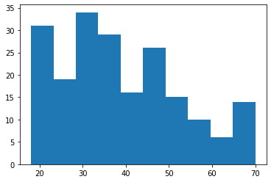

**Input:**

plt**.**hist(df['Annual Income (k$)'])

**Output:**

(array([24., 22., 28., 38., 30., 36., 8., 6., 4., 4.]),

array([ 15. , 27.2, 39.4, 51.6, 63.8, 76. , 88.2, 100.4, 112.6,

124.8, 137. ]),

)

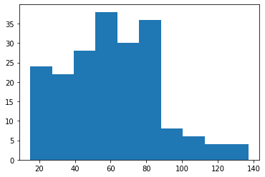

**Input:**

plt.hist(df['Spending Score (1-100)']) **Output:**

(array([16., 20., 10., 17., 35., 37., 11., 24., 14., 16.]),

array([ 1. , 10.8, 20.6, 30.4, 40.2, 50. , 59.8, 69.6, 79.4, 89.2, 99. ]),

)

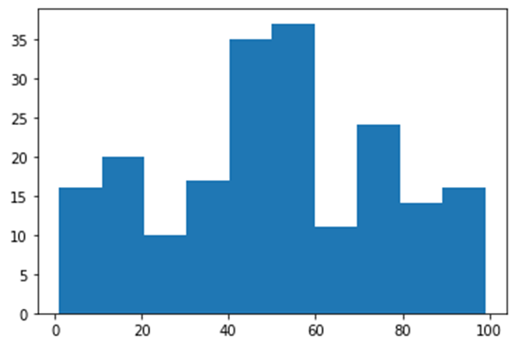

**Input:** sns**.**countplot(df['Gender']) **Output:**

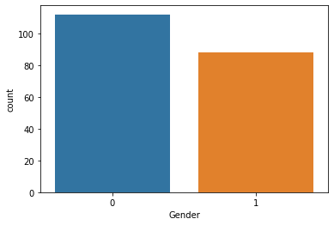

**Bi-Variate Analysis**

**Input:**

sns.scatterplot(df['Annual Income (k$)'], df['Spending Score (1-100)']) **Output:**

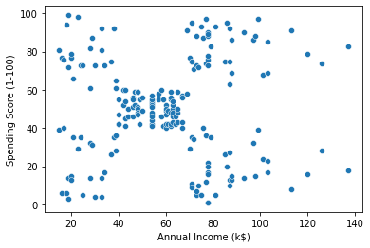

**Input:**

sns.barplot(df['Gender'], df['Age']) **Output:**

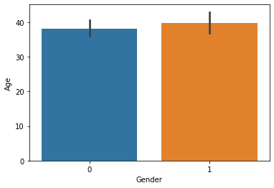 **Input:** sns**.**heatmap(df**.**corr(), annot **=** **True**) **Output:**

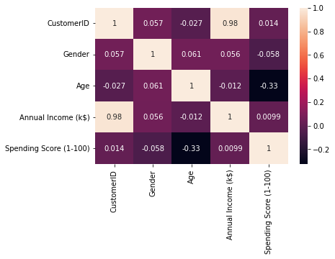

**Multi-variate Analysis Input:** sns.pairplot(df) **output:**

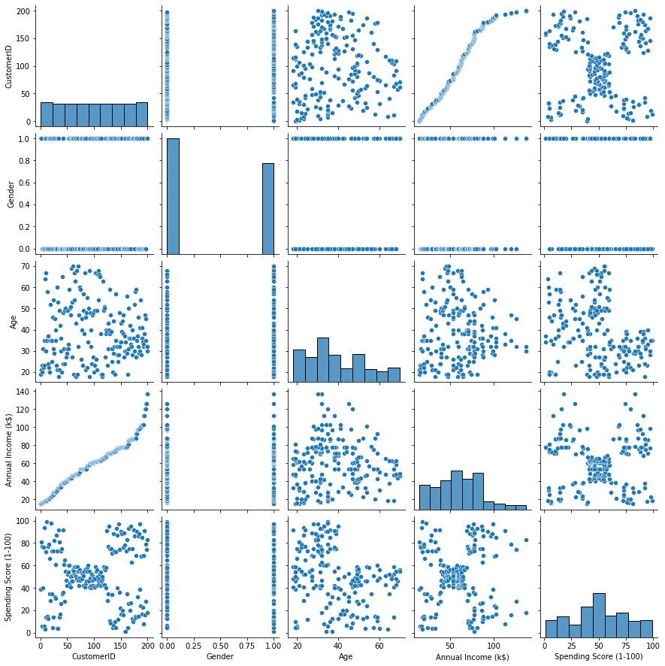

# Descriptive Statistics

**Input:** df**.**info() **Output:**

RangeIndex: 200 entries, 0 to 199 Data columns (total 5 columns):

# Column Non-Null Count Dtype

--- ------ -------------- -----

1. CustomerID 200 non-null int64
2. Gender 200 non-null int64
3. Age 200 non-null int64
4. Annual Income (k$) 200 non-null int64 4 Spending Score (1-100) 200 non-null int64 dtypes: int64(5) memory usage: 7.9 KB

**Input:** df**.**describe() **Output:**

**CustomerID Gender Age Annual Income (k$) Spending Score (1-100)**

|  |  |  |  |  |  |  |  |
| --- | --- | --- | --- | --- | --- | --- | --- |
|  | **CustomerID** | **Gender** | **Age** | **Annual Income (k$)** | | **Spending Score (1-100)** | |
| **count** | 200.000000 | 200.000000 | 200.000000 |  | 200.000000 |  | 200.000000 |
| **mean** | 100.500000 | 0.440000 | 38.850000 |  | 60.560000 |  | 50.200000 |
| **std** | 57.879185 | 0.497633 | 13.969007 |  | 26.264721 |  | 25.823522 |
| **min** | 1.000000 | 0.000000 | 18.000000 |  | 15.000000 |  | 1.000000 |
| **25%** | 50.750000 | 0.000000 | 28.750000 |  | 41.500000 |  | 34.750000 |
| **50%** | 100.500000 | 0.000000 | 36.000000 |  | 61.500000 |  | 50.000000 |
| **75%** | 150.250000 | 1.000000 | 49.000000 |  | 78.000000 |  | 73.000000 |
| **max** | 200.000000 | 1.000000 | 70.000000 |  | 137.000000 |  | 99.000000 |
|  |  |  |  |  |  |  |  |
| **Input:** |  |  |  |  |  |  |  |

df.skew() **Output:**

CustomerID 0.000000

Gender 0.243578

Age 0.485569

Annual Income (k$) 0.321843 Spending Score (1-100) -0.047220 dtype: float64

**Input:**df**.**kurt() **Output:**

CustomerID -1.200000

Gender -1.960375

Age -0.671573

Annual Income (k$) -0.098487 Spending Score (1-100) -0.826629 dtype: float64

**Input:**

df**.**corr()

**Output:**

|  |  |  |  |  |  |
| --- | --- | --- | --- | --- | --- |
|  | CustomerID | Gender | Age | Annual Income (k$) | Spending Score (1-100) |
| CustomerID | 1.000000 | 0.057400 | -0.026763 | 0.977548 | 0.013835 |
| Gender | 0.057400 | 1.000000 | 0.060867 | 0.056410 | -0.058109 |
| Age | -0.026763 | 0.060867 | 1.000000 | -0.012398 | -0.327227 |
| Annual Income (k$) | 0.977548 | 0.056410 | -0.012398 | 1.000000 | 0.009903 |
| Spending Score (1-100) | 0.013835 | -0.058109 | -0.327227 | 0.009903 | 1.000000 |

**Input:**df**.**var() **Output:**

CustomerID 3350.000000

Gender 0.247638

Age 195.133166

Annual Income (k$) 689.835578 Spending Score (1-100) 666.854271 dtype: float64

**Input:**df**.**std() **Output:**

CustomerID 57.879185

Gender 0.497633

Age 13.969007

Annual Income (k$) 26.264721 Spending Score (1-100) 25.823522 dtype: float64

**Checking for missing values**

**Input:**

df**.**isna()**.**sum()

**Output:**

CustomerID 0

Gender 0

Age 0

Annual Income (k$) 0 Spending Score (1-100) 0 dtype: int64

**Input:**df**.**isna()**.**sum()**.**sum() **Output:**

0 **Input:**df**.**duplicated()**.**sum() **Output:**

0

# Finding & Handling Ouliers

**Input:**

quantile **=** df**.**quantile(q **=** [0.25, 0.75]) quantile **Output:**

**CustomerID Gender Age Annual Income (k$) Spending Score (1-100)**

**0.25** 50.75 0.0 28.75 41.5 34.75

**0.75** 150.25 1.0 49.00 78.0 73.00

**Input:**

IQR **=** quantile**.**iloc[1] **-** quantile**.**iloc[0]

IQR **Output:**

CustomerID 99.50

Gender 1.00

Age 20.25

Annual Income (k$) 36.50 Spending Score (1-100) 38.25 dtype: float64

**Input:**

upper **=** quantile**.**iloc[1] **+** (1.5 **\***IQR) upper

**Output:**

CustomerID 299.500

Gender 2.500

Age 79.375

Annual Income (k$) 132.750 Spending Score (1-100) 130.375 dtype: float64 **Input:**

lower **=** quantile**.**iloc[0] **-** (1.5**\*** IQR) lower **Output:**

CustomerID -98.500

Gender -1.500

Age -1.625

Annual Income (k$) -13.250 Spending Score (1-100) -22.625 dtype: float64 **Input:**df**.**mean() **Output:**

CustomerID 100.50

Gender 0.44

Age 38.85

Annual Income (k$) 60.56 Spending Score (1-100) 50.20 dtype: float64 **Input:**df['Annual Income (k$)']**.**max() **Output:**

137

**Input:**sns**.**boxplot(df['CustomerID']) **Output:**

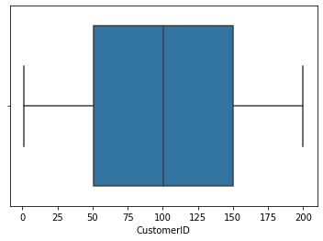 **Input:**sns**.**boxplot(df['Gender'])  **Output:**

 **Input:**sns**.**boxplot(df['Age'])  **Output:**

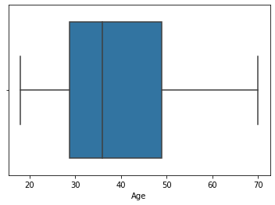 **Input:** sns**.**boxplot(df['Annual Income (k$)']) **Output:**

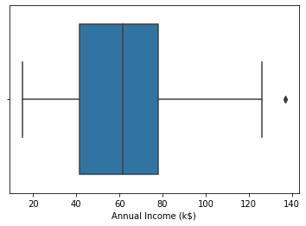 **Input:**

df['Annual Income (k$)'] **=** np**.**where(df['Annual Income (k$)'] **>** 132.750,

60.55, df['Annual Income (k$)']) sns**.**boxplot(df['Annual Income (k$)'])

**Output:**

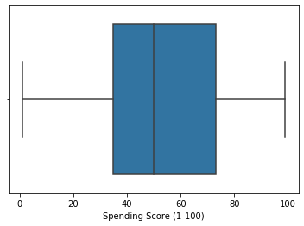

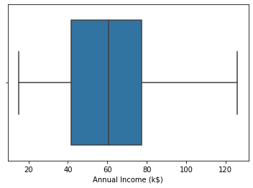 **Input:**df['Annual Income (k$)']**.**max() **Output:**126.0

**Input:** sns**.**boxplot(df['Spending Score (1-100)']) **Output:**

**Scaling the data**

**Input:**

**from** sklearn.preprocessing **import** StandardScaler ss **=** StandardScaler()**.**fit_transform(df) ss **Output:**

array([[-1.7234121 , 1.12815215, -1.42456879, -1.78843062, -0.43480148], [-1.70609137, 1.12815215, -1.28103541, -1.78843062, 1.19570407],

[-1.68877065, -0.88640526, -1.3528021 , -1.74850629, -1.71591298],

[-1.67144992, -0.88640526, -1.13750203, -1.74850629, 1.04041783],

[-1.6541292 , -0.88640526, -0.56336851, -1.70858195, -0.39597992],

[-1.63680847, -0.88640526, -1.20926872, -1.70858195, 1.00159627],

[-1.61948775, -0.88640526, -0.27630176, -1.66865761, -1.71591298],

[-1.60216702, -0.88640526, -1.13750203, -1.66865761, 1.70038436],

[-1.5848463 , 1.12815215, 1.80493225, -1.62873328, -1.83237767],

[-1.56752558, -0.88640526, -0.6351352 , -1.62873328, 0.84631002],

[-1.55020485, 1.12815215, 2.02023231, -1.62873328, -1.4053405 ],

[-1.53288413, -0.88640526, -0.27630176, -1.62873328, 1.89449216],

[-1.5155634 , -0.88640526, 1.37433211, -1.58880894, -1.36651894],

[-1.49824268, -0.88640526, -1.06573534, -1.58880894, 1.04041783],

[-1.48092195, 1.12815215, -0.13276838, -1.58880894, -1.44416206],

[-1.46360123, 1.12815215, -1.20926872, -1.58880894, 1.11806095],

[-1.4462805 , -0.88640526, -0.27630176, -1.5488846 , -0.59008772],

[-1.42895978, 1.12815215, -1.3528021 , -1.5488846 , 0.61338066],

[-1.41163905, 1.12815215, 0.94373197, -1.46903593, -0.82301709],

[-1.39431833, -0.88640526, -0.27630176, -1.46903593, 1.8556706 ],

[-1.3769976 , 1.12815215, -0.27630176, -1.42911159, -0.59008772],

[-1.35967688, 1.12815215, -0.99396865, -1.42911159, 0.88513158],

[-1.34235616, -0.88640526, 0.51313183, -1.38918726, -1.75473454],

[-1.32503543, 1.12815215, -0.56336851, -1.38918726, 0.88513158],

[-1.30771471, -0.88640526, 1.08726535, -1.26941425, -1.4053405 ],

[-1.29039398, 1.12815215, -0.70690189, -1.26941425, 1.23452563],

[-1.27307326, -0.88640526, 0.44136514, -1.26941425, -0.7065524 ],

[-1.25575253, 1.12815215, -0.27630176, -1.26941425, 0.41927286],

[-1.23843181, -0.88640526, 0.08253169, -1.22948991, -0.74537397],

[-1.22111108, -0.88640526, -1.13750203, -1.22948991, 1.42863343],

[-1.20379036, 1.12815215, 1.51786549, -1.18956557, -1.7935561 ],

[-1.18646963, -0.88640526, -1.28103541, -1.18956557, 0.88513158],

[-1.16914891, 1.12815215, 1.01549866, -1.06979256, -1.7935561 ],

[-1.15182818, 1.12815215, -1.49633548, -1.06979256, 1.62274124],

[-1.13450746, -0.88640526, 0.7284319 , -1.06979256, -1.4053405 ],

[-1.11718674, -0.88640526, -1.28103541, -1.06979256, 1.19570407],

[-1.09986601, -0.88640526, 0.22606507, -1.02986823, -1.28887582],

[-1.08254529, -0.88640526, -0.6351352 , -1.02986823, 0.88513158],

[-1.06522456, -0.88640526, -0.20453507, -0.91009522, -0.93948177],

[-1.04790384, -0.88640526, -1.3528021 , -0.91009522, 0.96277471],

[-1.03058311, -0.88640526, 1.87669894, -0.87017088, -0.59008772],

[-1.01326239, 1.12815215, -1.06573534, -0.87017088, 1.62274124],

[-0.99594166, 1.12815215, 0.65666521, -0.83024654, -0.55126616],

[-0.97862094, -0.88640526, -0.56336851, -0.83024654, 0.41927286],

[-0.96130021, -0.88640526, 0.7284319 , -0.83024654, -0.86183865],

[-0.94397949, -0.88640526, -1.06573534, -0.83024654, 0.5745591 ], [-0.92665877, -0.88640526, 0.80019859, -0.79032221, 0.18634349], [-0.90933804, -0.88640526, -0.85043527, -0.79032221, -0.12422899],

[-0.89201732, -0.88640526, -0.70690189, -0.79032221, -0.3183368 ],

[-0.87469659, -0.88640526, -0.56336851, -0.79032221, -0.3183368 ],

[-0.85737587, -0.88640526, 0.7284319 , -0.71047353, 0.06987881], [-0.84005514, 1.12815215, -0.41983513, -0.71047353, 0.38045129], [-0.82273442, -0.88640526, -0.56336851, -0.6705492 , 0.14752193],

[-0.80541369, 1.12815215, 1.4460988 , -0.6705492 , 0.38045129],

[-0.78809297, -0.88640526, 0.80019859, -0.6705492 , -0.20187212],

[-0.77077224, 1.12815215, 0.58489852, -0.6705492 , -0.35715836],

[-0.75345152, -0.88640526, 0.87196528, -0.63062486, -0.00776431],

[-0.73613079, 1.12815215, 2.16376569, -0.63062486, -0.16305055],

[-0.71881007, -0.88640526, -0.85043527, -0.55077619, 0.03105725],

[-0.70148935, 1.12815215, 1.01549866, -0.55077619, -0.16305055],

[-0.68416862, 1.12815215, 2.23553238, -0.55077619, 0.22516505],

[-0.6668479 , 1.12815215, -1.42456879, -0.55077619, 0.18634349],

[-0.64952717, -0.88640526, 2.02023231, -0.51085185, 0.06987881],

[-0.63220645, -0.88640526, 1.08726535, -0.51085185, 0.34162973],

[-0.61488572, 1.12815215, 1.73316556, -0.47092751, 0.03105725],

[-0.597565 , 1.12815215, -1.49633548, -0.47092751, 0.34162973],

[-0.58024427, -0.88640526, 0.29783176, -0.47092751, -0.00776431],

[-0.56292355, -0.88640526, 2.091999 , -0.47092751, -0.08540743],

[-0.54560282, 1.12815215, -1.42456879, -0.47092751, 0.34162973],

[-0.5282821 , -0.88640526, -0.49160182, -0.47092751, -0.12422899],

[-0.51096138, 1.12815215, 2.23553238, -0.43100318, 0.18634349],

[-0.49364065, -0.88640526, 0.58489852, -0.43100318, -0.3183368 ],

[-0.47631993, -0.88640526, 1.51786549, -0.39107884, -0.04658587],

[-0.4589992 , -0.88640526, 1.51786549, -0.39107884, 0.22516505],

[-0.44167848, 1.12815215, 1.4460988 , -0.23138149, -0.12422899],

[-0.42435775, 1.12815215, -0.92220196, -0.23138149, 0.14752193],

[-0.40703703, -0.88640526, 0.44136514, -0.23138149, 0.10870037],

[-0.3897163 , 1.12815215, 0.08253169, -0.23138149, -0.08540743],

[-0.37239558, -0.88640526, -1.13750203, -0.23138149, 0.06987881],

[-0.35507485, -0.88640526, 0.7284319 , -0.23138149, -0.3183368 ],

[-0.33775413, 1.12815215, 1.30256542, -0.23138149, 0.03105725],

[-0.3204334 , 1.12815215, -0.06100169, -0.23138149, 0.18634349],

[-0.30311268, 1.12815215, 2.02023231, -0.23138149, -0.35715836],

[-0.28579196, -0.88640526, 0.51313183, -0.23138149, -0.24069368],

[-0.26847123, -0.88640526, -1.28103541, -0.23138149, 0.26398661],

[-0.25115051, 1.12815215, 0.65666521, -0.23138149, -0.16305055],

[-0.23382978, -0.88640526, 1.15903204, -0.11160848, 0.30280817],

[-0.21650906, -0.88640526, -1.20926872, -0.11160848, 0.18634349],

[-0.19918833, -0.88640526, -0.34806844, -0.07168415, 0.38045129],

[-0.18186761, -0.88640526, 0.80019859, -0.07168415, -0.16305055],

[-0.16454688, -0.88640526, 2.091999 , -0.03175981, 0.18634349],

[-0.14722616, 1.12815215, -1.49633548, -0.03175981, -0.35715836],

[-0.12990543, 1.12815215, 0.65666521, 0.00816453, -0.04658587],

[-0.11258471, -0.88640526, 0.08253169, 0.00816453, -0.39597992],

[-0.09526399, -0.88640526, -0.49160182, 0.00816453, -0.3183368 ], [-0.07794326, 1.12815215, -1.06573534, 0.00816453, 0.06987881], [-0.06062254, -0.88640526, 0.58489852, 0.00816453, -0.12422899], [-0.04330181, -0.88640526, -0.85043527, 0.00816453, -0.00776431],

[-0.02598109, 1.12815215, 0.65666521, 0.04808886, -0.3183368 ],

[-0.00866036, 1.12815215, -1.3528021 , 0.04808886, -0.04658587],

[ 0.00866036, -0.88640526, -1.13750203, 0.0880132 , -0.35715836],

[ 0.02598109, -0.88640526, 0.7284319 , 0.0880132 , -0.08540743],

[ 0.04330181, 1.12815215, 2.02023231, 0.0880132 , 0.34162973], [ 0.06062254, 1.12815215, -0.92220196, 0.0880132 , 0.18634349],

[ 0.07794326, 1.12815215, 0.7284319 , 0.0880132 , 0.22516505], [ 0.09526399, -0.88640526, -1.28103541, 0.0880132 , -0.3183368 ],

[ 0.11258471, -0.88640526, 1.94846562, 0.12793754, -0.00776431],

[ 0.12990543, 1.12815215, 1.08726535, 0.12793754, -0.16305055],

[ 0.14722616, 1.12815215, 2.091999 , 0.12793754, -0.27951524],

[ 0.16454688, 1.12815215, 1.94846562, 0.12793754, -0.08540743],

[ 0.18186761, 1.12815215, 1.87669894, 0.12793754, 0.06987881],

[ 0.19918833, -0.88640526, -1.42456879, 0.12793754, 0.14752193],

[ 0.21650906, -0.88640526, -0.06100169, 0.16786187, -0.3183368 ],

[ 0.23382978, 1.12815215, -1.42456879, 0.16786187, -0.16305055],

[ 0.25115051, -0.88640526, -1.49633548, 0.20778621, -0.08540743],

[ 0.26847123, -0.88640526, -1.42456879, 0.20778621, -0.00776431],

[ 0.28579196, -0.88640526, 1.73316556, 0.20778621, -0.27951524],

[ 0.30311268, -0.88640526, 0.7284319 , 0.20778621, 0.34162973],

[ 0.3204334 , -0.88640526, 0.87196528, 0.28763488, -0.27951524],

[ 0.33775413, -0.88640526, 0.80019859, 0.28763488, 0.26398661],

[ 0.35507485, 1.12815215, -0.85043527, 0.28763488, 0.22516505],

[ 0.37239558, -0.88640526, -0.06100169, 0.28763488, -0.39597992],

[ 0.3897163 , -0.88640526, 0.08253169, 0.36748356, 0.30280817],

[ 0.40703703, 1.12815215, 0.010765 , 0.36748356, 1.58391968],

[ 0.42435775, -0.88640526, -1.13750203, 0.40740789, -0.82301709],

[ 0.44167848, -0.88640526, -0.56336851, 0.40740789, 1.04041783],

[ 0.4589992 , 1.12815215, 0.29783176, 0.44733223, -0.59008772],

[ 0.47631993, 1.12815215, 0.08253169, 0.44733223, 1.73920592],

[ 0.49364065, 1.12815215, 1.4460988 , 0.44733223, -1.52180518],

[ 0.51096138, 1.12815215, -0.06100169, 0.44733223, 0.96277471],

[ 0.5282821 , 1.12815215, 0.58489852, 0.44733223, -1.5994483 ],

[ 0.54560282, 1.12815215, 0.010765 , 0.44733223, 0.96277471],

[ 0.56292355, -0.88640526, -0.99396865, 0.48725657, -0.62890928],

[ 0.58024427, -0.88640526, -0.56336851, 0.48725657, 0.80748846],

[ 0.597565 , 1.12815215, -1.3528021 , 0.5271809 , -1.75473454],

[ 0.61488572, -0.88640526, -0.70690189, 0.5271809 , 1.46745499],

[ 0.63220645, -0.88640526, 0.36959845, 0.5271809 , -1.67709142],

[ 0.64952717, 1.12815215, -0.49160182, 0.5271809 , 0.88513158],

[ 0.6668479 , 1.12815215, -1.42456879, 0.56710524, -1.56062674],

[ 0.68416862, -0.88640526, -0.27630176, 0.56710524, 0.84631002],

[ 0.70148935, -0.88640526, 1.30256542, 0.60702958, -1.75473454],

[ 0.71881007, 1.12815215, -0.49160182, 0.60702958, 1.6615628 ],

[ 0.73613079, -0.88640526, -0.77866858, 0.64695391, -0.39597992],

[ 0.75345152, -0.88640526, -0.49160182, 0.64695391, 1.42863343],

[ 0.77077224, 1.12815215, -0.99396865, 0.68687825, -1.48298362],

[ 0.78809297, 1.12815215, -0.77866858, 0.68687825, 1.81684904],

[ 0.80541369, 1.12815215, 0.65666521, 0.68687825, -0.55126616],

[ 0.82273442, -0.88640526, -0.49160182, 0.68687825, 0.92395314],

[ 0.84005514, -0.88640526, -0.34806844, 0.72680259, -1.09476801],

[ 0.85737587, 1.12815215, -0.34806844, 0.72680259, 1.54509812],

[ 0.87469659, 1.12815215, 0.29783176, 0.72680259, -1.28887582],

[ 0.89201732, 1.12815215, 0.010765 , 0.72680259, 1.46745499], [ 0.90933804, -0.88640526, 0.36959845, 0.72680259, -1.17241113], [ 0.92665877, -0.88640526, -0.06100169, 0.72680259, 1.00159627], [ 0.94397949, -0.88640526, 0.58489852, 0.72680259, -1.32769738],

[ 0.96130021, -0.88640526, -0.85043527, 0.72680259, 1.50627656],

[ 0.97862094, 1.12815215, -0.13276838, 0.72680259, -1.91002079], [ 0.99594166, -0.88640526, -0.6351352 , 0.72680259, 1.07923939], [ 1.01326239, 1.12815215, -0.34806844, 0.72680259, -1.91002079],

[ 1.03058311, -0.88640526, -0.6351352 , 0.72680259, 0.88513158], [ 1.04790384, -0.88640526, 1.23079873, 0.76672692, -0.59008772],

[ 1.06522456, -0.88640526, -0.70690189, 0.76672692, 1.27334719], [ 1.08254529, 1.12815215, -1.42456879, 0.8465756 , -1.75473454], [ 1.09986601, -0.88640526, -0.56336851, 0.8465756 , 1.6615628 ], [ 1.11718674, 1.12815215, 0.80019859, 1.00627294, -0.93948177], [ 1.13450746, -0.88640526, -0.20453507, 1.00627294, 0.96277471], [ 1.15182818, 1.12815215, 0.22606507, 1.04619728, -1.17241113],

[ 1.16914891, -0.88640526, -0.41983513, 1.04619728, 1.73920592],

[ 1.18646963, -0.88640526, -0.20453507, 1.08612162, -0.90066021],

[ 1.20379036, 1.12815215, -0.49160182, 1.08612162, 0.49691598],

[ 1.22111108, 1.12815215, 0.08253169, 1.08612162, -1.44416206],

[ 1.23843181, 1.12815215, -0.77866858, 1.08612162, 0.96277471],

[ 1.25575253, 1.12815215, -0.20453507, 1.08612162, -1.56062674],

[ 1.27307326, 1.12815215, -0.20453507, 1.08612162, 1.62274124],

[ 1.29039398, -0.88640526, 0.94373197, 1.12604595, -1.44416206],

[ 1.30771471, -0.88640526, -0.6351352 , 1.12604595, 1.38981187],

[ 1.32503543, 1.12815215, 1.37433211, 1.12604595, -1.36651894],

[ 1.34235616, 1.12815215, -0.85043527, 1.12604595, 0.72984534],

[ 1.35967688, 1.12815215, 1.4460988 , 1.32566764, -1.4053405 ],

[ 1.3769976 , 1.12815215, -0.27630176, 1.32566764, 1.54509812],

[ 1.39431833, -0.88640526, -0.13276838, 1.48536498, -0.7065524 ],

[ 1.41163905, -0.88640526, -0.49160182, 1.48536498, 1.38981187],

[ 1.42895978, 1.12815215, 0.51313183, 1.52528932, -1.36651894],

[ 1.4462805 , -0.88640526, -0.70690189, 1.52528932, 1.46745499],

[ 1.46360123, -0.88640526, 0.15429838, 1.56521366, -0.43480148],

[ 1.48092195, 1.12815215, -0.6351352 , 1.56521366, 1.81684904],

[ 1.49824268, -0.88640526, 1.08726535, 1.64506233, -1.01712489],

[ 1.5155634 , 1.12815215, -0.77866858, 1.64506233, 0.69102378],

[ 1.53288413, -0.88640526, 0.15429838, 1.724911 , -1.28887582],

[ 1.55020485, -0.88640526, -0.20453507, 1.724911 , 1.35099031],

[ 1.56752558, -0.88640526, -0.34806844, 1.724911 , -1.05594645],

[ 1.5848463 , -0.88640526, -0.49160182, 1.724911 , 0.72984534],

[ 1.60216702, 1.12815215, -0.41983513, 2.12415437, -1.63826986],

[ 1.61948775, -0.88640526, -0.06100169, 2.12415437, 1.58391968],

[ 1.63680847, -0.88640526, 0.58489852, 2.40362473, -1.32769738],

[ 1.6541292 , -0.88640526, -0.27630176, 2.40362473, 1.11806095],

[ 1.67144992, -0.88640526, 0.44136514, 2.64317075, -0.86183865],

[ 1.68877065, 1.12815215, -0.49160182, 2.64317075, 0.92395314],

[ 1.70609137, 1.12815215, -0.49160182, 0.03012291, -1.25005425], [ 1.7234121 , 1.12815215, -0.6351352 , 0.03012291, 1.27334719]]) **Clustering Algorithm**

**Input:**

**from** sklearn.cluster **import** KMeans TWSS **=** [] k **=** list(range(2,9)) **for** i **in** k:

kmeans **=** KMeans(n_clusters **=** i , init **=** 'k-means++') kmeans**.**fit(df)

TWSS**.**append(kmeans**.**inertia_)

TWSS **Output:**

[381507.64738523855,

268062.55433747417,

191550.08627670942,

153777.55391034693,

119166.15727643928,

101239.32626154403,

85744.90139221892] **Input:**plt**.**plot(k,TWSS, 'ro--') **Output:**

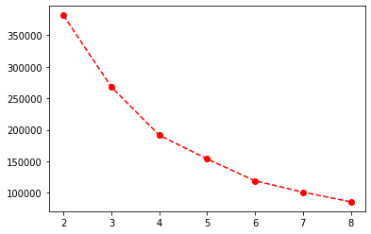

model **=** KMeans(n_clusters **=** 4) **Input:**model**.**fit(df)  **Output:**

KMeans(n_clusters=4)

**Input:**mb **=** pd**.**Series(model**.**labels_) df['Cluster'] **=** mb df  **Output:**

**CustomerID Gender Age Annual Income (k$) Spending Score (1-100) Cluster**

1. 1 1 19 15.00 39 2
2. 2 1 21 15.00 81 2

**CustomerID Gender Age Annual Income (k$) Spending Score (1-100) Cluster**

1. 3 0 20 16.00 6 2
2. 4 0 23 16.00 77 2
3. 5 0 31 17.00 40 2

**...** ... ... ... ... ... ...

1. 196 0 35 120.00 79 3
2. 197 0 45 126.00 28 1
3. 198 1 32 126.00 74 3
4. 199 1 32 60.55 18 1
5. 200 1 30 60.55 83 3

## 200 rows × 6 columns